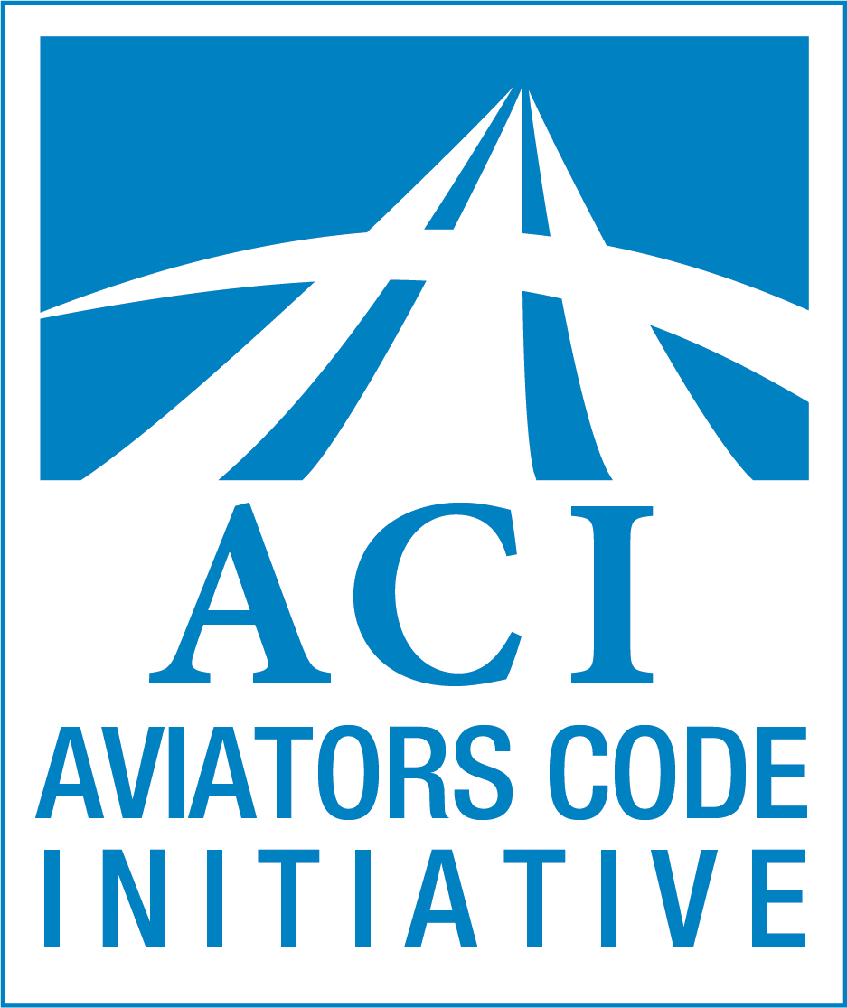

UAS Pilots Code

Condensed Version
Version 1.0

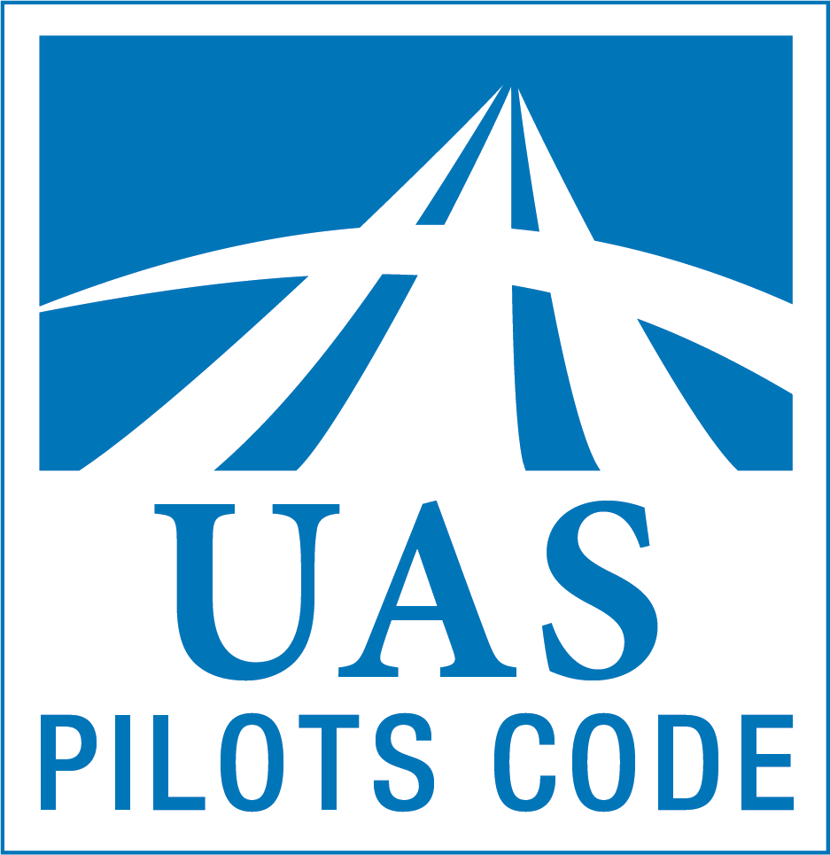

Tools to advance UAS safety and professionalism

Permanent Editorial Board
of the
Aviators Code Initiative
and the
University Aviation Association

Dear UAS Pilot:
This letter introduces version 1.0 of the UAS Pilots Code (UASPC). Developed by a team of aviation and UAS professionals, the UASPC recommends operating practices to enhance the quality and safety of your operations. The UASPC applies to a range of operating environments and experience levels, from the UAS novice to experienced UAS pilots.
Pilot conduct and professionalism affect the entire aviation community, including its safety culture. Correspondingly, organizational safety culture affects pilot conduct. A voluntary, aspirational code of conduct promotes pilot proficiency and operational safety. The UASPC is just such a tool: a set of guidelines, and recommended practices adaptable to each pilot and organizational need.
The UASPC reflects years of safety practices and lessons learned in manned and unmanned aviation that are applicable to UAS operations. We encourage you to adopt it, and to commit to the highest principles of aviation safety.
The UASPC was developed as a volunteer effort and is provided as a free public service.
Introduction
The UAS Pilots Code (UASPC) offers recommendations to advance flight safety, ground safety, airmanship, and professionalism. It presents a vision of excellence for UAS pilots and operators, and includes general guidance for all types of UAS. The UASPC offers broad guidance—a set of values—to help a pilot interpret and apply standards and regulations, and to confront the real world challenges to avoid incidents and accidents. It is designed to help UAS pilots develop standard operating procedures (SOPs), effective risk management, safety management systems (SMS), and to encourage UAS pilots to consider themselves aviators and participants in the broader aviation community.
The FAA Airman Certification Standards (ACS) establish the pilot certification testing standards. Regulations and standards alone, however, do not necessarily prepare a pilot to handle every unusual or unanticipated situations, especially those beyond the scope of standard procedures, checklists or operating manuals. The UASPC’s principles complement and underscore legal requirements. Because regulation may lag behind technology developments, the UASPC can be particularly helpful in providing guidance.
The UASPC is designed to be a living document, intended to be updated periodically to reflect changes in aviation practices and the aviation environment.
This document is applicable to civil unmanned aircraft system (UAS) pilots, ground crew including visual observers, operations managers, safety officers, and other interested or responsible parties. The UASPC may also serve as a supplemental resource for other UAS operations.
The UASPC is a model, not a standard. Users may customize this document to suit their needs including title, length, and organization, and level of technical detail or sophistication. The UASPC is most effective if users commit to the pursuit of professionalism as well as a firm grasp of the fundamentals of UAS flight and flight safety. Three versions of the UASPC are available:
- Annotated Version - unabridged, with supplemental materials and extensive supporting endnotes, including drafting considerations,
- Condensed Version - without annotation, intended for pilot implementation, and
- Abbreviated Version - core principles only, introducing and promoting the UASPC.
Organization: The UASPC has seven sections, each presenting Principles and Sample Recommended Practices (SRPs).
The Sections:
I. General Responsibilities of UAS Pilots
II. Manned Aircraft & People on the Surface
III. Training and Proficiency
IV. Security and Privacy
V. Environmental Issues
VI. Use of Technology
VII. Advancement of UAS Aviation
The Principles: The Principles are recommended best practices addressing safety, training, risk management, and technology. General and concise, the Principles are designed to provide a foundation for building professionalism and a safety culture.
The Sample Recommended Practices: Sample Recommended Practices (SRPs) are suggestions for applying the principles of the UASPC and tailoring them to individuals and organizations. SRPs may be reordered, modified, or eliminated when not applicable, to satisfy the unique capabilities and requirements of each pilot, mission, unmanned aircraft, organization, and flight environment.
Benefits of the UASPC: The UASPC benefits UAS pilots and the UAS community by:
- recommending practices to support safety and professionalism among UAS pilots,
- encouraging UAS pilots to recognize themselves as aviators and members of the broader aviation community,
- promoting improved training, airmanship, conduct, personal responsibility, and pilot contributions to the UAS community and society at large,
- encouraging the development and adoption of ethical practices and good judgment,
- advancing self-regulation and responsibility in the UAS community, and
- supporting improved communications between pilots, regulators, and others in the UAS industry to further enhance safety within the National Airspace System (NAS).
References to civil aviation authorities (CAAs) and the FAA are used as examples. In all jurisdictions, applicable laws and regulations must be followed.

UAS Pilots Code
Principles and
Sample Recommended Practices

I. General Responsibilities of UAS Pilots
UAS pilots should:
- make safety a top priority,
- seek excellence in airmanship (knowledge, skill, ability, and attitude that promote safe and efficient operations),
c. adopt sound principles of aeronautical decision-making (ADM) (the process used by pilots to consistently determine the best course of action in response to the circumstances), and develop and exercise good judgment,
d. use sound principles of risk management,
e. maintain situational awareness (the accurate perception and understanding of your operation and environment), and adhere to prudent operating practices,
f. aspire to professionalism,
g. act with responsibility, integrity, and courtesy, and
h. adhere to applicable laws, regulations, and industry guidance.
Explanation: These General Responsibilities serve as a preamble to the UASPC’s other principles.

Sample Recommended Practices:
- Recognize, plan for and accept the costs of implementing effective safety practices.
- Organizations of any size and scope should apply the principles of a safety management system (SMS): understand the risks in your operations, take steps to control them, and monitor operations to assure that these controls are working.
- Improve safety margins and reduce unnecessary risk by planning and flying conservatively.
- Recognize that use of a visual observer enhances safety, even when not required.
- Do not carry hazardous payloads unless authorized.
- Do not assume that the altitudes prescribed in UAS Facility Maps are necessarily accurate or appropriate for flight.
- Create an emergency response plan, and implement it in the event of an incident or accident.
- Identify and adapt to changing flight conditions based on airmanship, sound principles of UAS safety and risk management. Be prepared to alter your flight plan or discontinue your flight accordingly.
- Ensure UAS flight controllability is not adversely affected by payload weight, placement, and loading. Follow manufacturer's instructions if provided. In the absence of provided guidance, use conservative loading practices.
- Consider conducting a stability and controllability test at the start of each flight.
- Understand the unique relationship between UAS piloting and aeronautical decision-making, ethical choices, and flight safety.
- Recognize the difficulty of visually estimating UAS altitude and distance.
- Incorporate Threat and Error Management (TEM - process of detecting and responding to threats and errors) into your operation to aid in identifying errors and external threats that could compromise safety.
- Employ Crew Resource Management (CRM - the effective use of all available resources: human resources, hardware, and information) techniques to foster effective crew coordination, teamwork, and enhance safety culture.
- Consider the effect of weather such as wind, precipitation, and temperature on power, fuel reserves, and performance, and their impact on the safe completion of flight.
- Refuse to operate a UAS that is unsafe for flight because of mechanical, electrical or control system discrepancies, failure to meet applicable inspection requirements, airworthiness (suitability for safe flight), or any anomaly that adversely affects airworthiness.
- Discontinue UAS operations in the event of potential conflict with other aircraft, mechanical anomaly, low power or fuel condition, adverse weather, or any other condition that may compromise safety.
- Use risk management tools to identify, evaluate and mitigate the effects of hazards, and do not subject anyone to unnecessary risks.
- Keep operations well clear of airports, heliports, and seaplane bases. Conduct such operations only when safety can be reasonably assured. Where applicable, make notification, and obtain authorization from proper authorities.
- Recognize the restrictions associated with flying near airports or other aircraft, in controlled airspace, over people, in inclement weather (including reduced visibility environments), and at night. Be aware of the increased risk associated with flying in congested, urban, or confined areas; near obstacles; over water, rugged, mountainous, or forested terrain; in high density altitude conditions; and in other circumstances that may adversely affect safety.
- Have a ground safety plan for and ready access to appropriate fire suppression and other emergency equipment and the ability to contact emergency services.
- Recognize that aviation or other charts may not accurately reflect all obstructions and hazards that could affect UAS operations. Maintain chart currency. Supplement aeronautical charts with visual observers, site survey, and other mapping resources.
- Prevent distractions that could lead to errors and compromise safety by limiting unnecessary tasks or communication during launch, recovery, and other critical phases of flight.
- Where practicable, enhance visibility through appropriate use of aircraft lighting and bright paint schemes or markings. Ensure aircraft lighting does not impair night vision.
- See and be seen. Maintain a robust scan and practice techniques for seeing and avoiding other aircraft. Recognize that manned aircraft pilots are unlikely to anticipate or see your UAS.
- Fly at an altitude appropriate to the mission. Consider the risks associated with higher altitude flights, such as higher wind speeds, maintaining separation from other aircraft and potential crash impact velocity with respect to people, structures or property on the surface. Be aware of the risks of flying at low altitudes, such as manned operations, obstructions, turbulence induced by urban structures, and other relevant hazards.
- Make an honest evaluation of your mental and physical fitness a precondition of each flight—for example, by using the I’M SAFE (Illness, Medication, Stress, Alcohol, Fatigue, Emotion) checklist.
- Recognize that some emergency scenarios should not be practiced in the absence of an experienced UAS pilot or knowledgeable mentor.
- Improve situational awareness by using sound principles of airmanship, crew resource management, scenario-based training, and risk management.
- Become familiar with and monitor appropriate aviation frequencies to enhance your awareness of other aircraft in proximity to your UAS operation. Where authorized, accurately inform other pilots of your position and intentions on appropriate frequencies, and air traffic control of emergencies including loss of separation with other aircraft, or loss of control of your UAS.
- For flights to, from, at, or in proximity to airports, contact the controlling facility, and review applicable Chart Supplements (formerly Airport Facilities/Directory (AF/D)) and other resources to ascertain each airport’s environment, operational conditions, surrounding terrain and obstructions.
- Remain aware of changing or deteriorating weather and other circumstances that may make continued flight unsafe. Be particularly aware of crosswinds, tailwinds, and gusty wind/turbulent conditions when landing, departing, or hovering. In such cases, make an informed risk management decision whether to continue the flight.
- Avoid the flow of all manned aircraft traffic unless directed otherwise by air traffic control (ATC). For off-airport flights, include review of relevant maps, and local knowledge.
- Plan for the possibility that curious onlookers may approach your UAS operation creating a potential distraction or hazard.
- Check relevant Notices to Airmen (NOTAMs) including Temporary Flight Restrictions (TFRs) prior to commencing flight operations, and update as practicable during extended or multi-flight operations. When appropriate, file and update NOTAMs regarding your flight.
- Complete a comprehensive preflight inspection prior to commencing flight operations to determine that the UAS is airworthy.
- Ensure that your aircraft’s firmware (software that controls essential system functions) and other software is up to date. Recognize that various systems may require update, including aircraft, ground station, control application or display tablet and power supply. Be sure you understand the impact of any firmware/software updates.
- As part of preflight planning, identify options for emergency landing locations.
- Develop, use, periodically review, and refine checklists and personal minimums (an operational envelope within which the pilot is adequately trained and competent) for all phases of flight. Review these materials regularly with an experienced UAS pilot or knowledgeable mentor.
- Before takeoff, understand your mission plan. The mission plan should include consideration of the objectives, pilot capabilities, UAS platform, operations area, environmental conditions, and other external factors affecting flight safety.
- Maintain an altitude and configuration that will permit an emergency landing without undue hazard to people or property.
- As part of preflight planning, identify locations where either manned or unmanned aircraft may be encountered and develop contingencies for avoidance. UAS pilots may encounter VFR aircraft at lower than normal altitudes during periods of reduced visibility or limited ceiling height.
- Be aware of personal susceptibility to, and seek to avoid or manage distraction, fatigue, and stress.
- Be aware of your personal susceptibility to attitudes that adversely influence good aeronautical decision-making.
- Develop conservative personal operating limitations reflecting experience, and proficiency, especially in challenging conditions.
- Approach UAS operations with seriousness, commitment, and diligence, recognizing that your actions may jeopardize the lives, well-being, and property of people in manned aircraft and on the surface.
- Understand and comply with the privileges and limitations of your certificates, authorizations, and waivers.
- Adhere to rules and operating practices of your airport or operating location, employer, flight school, or flight center, and recommendations from recognized UAS organizations.
- Maintain awareness of local laws, regulations, or ordinances that may affect UAS operations.
- As soon as practicable but no later than 10 days after an occurrence, report UAS accidents to the FAA; immediately report accidents that meet NTSB thresholds to the NTSB, and report near mid air collisions to the FAA’s Near Mid Air Collision System (NMACS), and/or safety incidents via the Aviation Safety Reporting System (ASRS).
- Comply with manufacturer’s operating manuals and instructions, especially with regard to performance, limitations, and abnormal/emergency conditions.
- Understand the requirements and benefits of complying with manufacturer’s recommended inspections and maintenance guidance, and in the absence thereof, consider developing a scheduled maintenance plan that achieves the longest and safest service life of the UAS.
- Complete post-flight procedures such as ATC flight completion notification, cancellation of flight plan, post-flight inspections, and discrepancy reporting. Keep a log of UAS maintenance and operational status and ensure that appropriate measures are taken to correct system deficiencies.
- Identify safety and compliance issues, and communicate them appropriately.
- Confirm availability of all required or recommended ground support equipment before initiating flight operations.
- Learn and remain familiar with lost control link, stabilization, and other automation failure procedures. Follow manufacturer’s or builder’s instructions if provided.
- Use caution when charging, transporting, discharging, storing, disposing or otherwise handling batteries to minimize risk to persons or property.

**

II. Manned Aircraft and People on the Surface
UAS pilots should:
a. manage and avoid unnecessary risk to manned aircraft, and to people and property on the surface, and
b. avoid operations that may alarm or disturb people on the surface or in manned aircraft.
Explanation: UAS pilots must avoid harming persons or property. Civil aviation authorities accommodate flight operations with the expectation that UAS pilots exercise due care and adequately mitigate risks to others and their property.

Sample Recommended Practices:
- Recognize that responsible planning precedes every UAS mission.
- Give right-of-way to all manned aircraft.
- Do not operate over people without authorization, proper training and equipment. Consider using a covered area or safety line to segregate flight operations from non-participants and minimize risk to people.
- To the extent practicable, use aircraft and payloads composed of frangible or energy-absorbing materials, propeller guards, and other available mechanisms to mitigate risk of injury to persons.
- Monitor people within the proximity of your intended operations closely. Keep them informed and clear of potential UAS hazards including propellers, rotors, and hazardous materials.
- UAS pilots and crew members should consider the use of protective, highly-visible clothing (such as safety vests and other markers), helmets, and eye protection. Use high visibility area markers such as traffic cones to denote takeoff and landing areas to protect everyone.
- Maintain adequate insurance coverage for all UAS operations. Understand and comply with all policy terms and limitations.
- Brief all participants on the planned UAS operation to mitigate the potential for injury.
- Instruct non-crewmembers to avoid touching or obstructing equipment and payload.
- Develop and maintain an operations manual to help identify and describe the system and operations characteristics, including specifications of the aircraft, responsibilities of the crew, scope of operational decision-making authority, pre- and post-flight checklists, and processes that promote risk management.
- Collision avoidance may require UAS pilots to perform an aggressive maneuver. During such maneuvers be aware of the increased risk of impact with aircraft and people or structures on the surface.
- Consider the use of visual observers to aid the UAS pilot in maintaining situational awareness as well as identifying both airborne and ground hazards.
- Ensure adequate separation from people, other aircraft, and unauthorized airspace.
- Avoid manned aircraft traffic patterns unless authorized and operationally required.
- Act professionally towards all people affected by your UAS operations.
- Tactfully disclose risks to all affected parties and address their concerns regarding flight operations, and seek to accommodate their needs.
- Take responsibility for any harm you may cause to people, property, or wildlife.

**
III. Training and Proficiency
UAS pilots should:
a. participate in regular training to maintain and improve proficiency beyond minimum requirements,
b. pursue a rigorous, lifelong course of aviation study,
c. remain vigilant and avoid complacency,
d. train to recognize and effectively respond to emergencies, and
e. maintain an accurate log to document your experience and improve future aeronautical decision-making and risk management.
Explanation: Training and proficiency underlie aviation safety. Regular training is a primary component of proficiency and should include both air and ground training. Training and proficiency each contribute significantly to flight safety and neither can substitute for the other.

Sample Recommended Practices:
- Develop and follow a training regimen that incorporates the assessment of your progress. Obtain guidance and seek feedback from an experienced UAS pilot or mentor.
- Obtain equipment and operational training before commencing flight operations.
- Learn appropriate use of the UAS manufacturer’s manual or instructions to conduct flight planning, properly secure payloads, determine aircraft limitations, performance, and power or fuel requirements, assess weight and balance, and safely undertake flight operations.
- Recognize applicable safety or informational placards placed on the UAS platform, components, attachments, related devices, or manuals. Understand and comply with all placard instructions, limitations, or information. Ensure placards are visible and properly affixed.
- Become familiar with orientation or aircraft status lighting and their related meaning to enhance situational awareness.
- Learn and adhere to airspace classes, requirements, and restrictions.
- Integrate manual flight, autonomous flight, and scenario-based training (real-world situations that meet flight training objectives in an operational environment) in the training regime.
- Incorporate simulation into your training program, with an emphasis on abnormal/emergency conditions, including loss-of-control and traffic conflicts.
- Learn how your automated systems work and understand their limitations.
- Learn and practice obstacle and wire avoidance techniques.
- Complete training appropriate to specialized operations or unique mission requirements.
- Develop a systematic approach to obtaining timely and reliable weather information and evaluating flight conditions.
- Learn and remain familiar with aviation regulations and associated guidance material. Understand their intent and implications.
- Train for flight over challenging environments such as water, remote areas, desert, or mountainous terrain, woodlands, urban areas, and understand that such environments may compromise or degrade the performance or functionality of some UAS.
- Learn how to determine and adhere to airworthiness requirements for each UAS you fly, and confirm its airworthiness before each flight by conducting a thorough preflight inspection.
- Develop a practical understanding of the mechanics, systems, and unique risks of each UAS you fly.
- Conduct a periodic review of recent accidents, incidents, and unsafe conditions focusing on probable causes.
- Periodically demonstrate mastery of applicable Airman Certification Standards (ACS); study and train to exceed ACS requirements.
- Select an appropriate training area, taking into consideration property ownership, airspace, local restrictions, and potential safety and privacy issues.
- Fly often enough to maintain proficiency consistent with your certificates and authorizations.
- Use flight simulators and other training devices that appropriately reflect your system’s automation.
- Invite and accept constructive criticism from your fellow aviators and provide the same when asked.
- Attend aviation training programs, FAA Pilot Proficiency Program (“WINGS”) safety seminars, and complete online FAAST courses and training materials.
- Participate in organizations that can improve your UAS platform knowledge and flight skills regarding their capabilities, limitations, and safe operation.
- Achieve and maintain proficiency in the operation of UAS systems, manual flight controls and automation.
- Commit to and maintain an ongoing course of training in both flight skills and aeronautical knowledge.
- Register at www.faasafety.gov to receive announcements of safety meetings and literature, and to review appropriate safety courses.
- Stay current with relevant aviation publications.
- Obtain adequate training before flying an unfamiliar UAS, or operating unfamiliar UAS automation or systems, even if you have flown a similar make or model in the past.
- Ensure before each flight that your safety, failsafe, and other settings are configured appropriately.
- UAS pilots who are not certificated to fly manned aircraft may benefit from introductory ground and flight training in manned flight. Such training will help the UAS pilot better understand the unique challenges of operating manned aircraft, including detecting and avoiding UAS operations.
- Manned aircraft pilots who intend to fly UAS should obtain additional training to address the unique challenges of conducting UAS operations. Such training may cover command and control (C2) systems, including telemetry, data management, failure modes, autonomous operations, and aerodynamics.
- Recognize the vulnerability of UAS to wind, turbulence, and other weather conditions, and how these effects may vary in fixed-wing, multirotor, and hybrid unmanned aircraft.
- Practice emergency procedures regularly. Recognize that improper responses to simulated emergencies can lead to actual emergencies.
- Understand your authority and responsibilities as a UAS pilot including recognizing an emergency when it occurs, and communicating that knowledge to crew, bystanders or external authorities as appropriate.
- Understand and train to use appropriate procedures in the event of system malfunctions or failures such as electrical, rotor, propulsion, or loss of control link.
- Debrief each flight. Review your objectives, identify mistakes and any unnecessary risks to enhance safety and improve your performance on future flights. Maintain a log to track errors and lessons learned during each flight.

**
IV. Security and Privacy
UAS pilots should:
a. take measures to maintain the security of persons and property affected by UAS activities,
b. remain vigilant and immediately report suspicious, reckless, or illegal UAS activities,
c. become familiar with current security and privacy rules and best practices,
d. avoid controlled and special activity/special use airspace except when approved or necessary in an emergency, and
e. recognize and respect the public’s reasonable expectation of privacy.
Explanation: Security pertains to measures taken to protect people, property, and information from criminal or terrorist acts. It also includes measures taken by UAS pilots to avoid inadvertently becoming a real or perceived security threat. In addition, UAS operations present a new and unique potential to compromise privacy. This section addresses the UAS pilot’s essential role in promoting national security, preventing criminal acts, and respecting privacy rights.

Sample Recommended Practices:
- Secure your UAS if it will be unattended.
- Determine the ownership of property on which you desire to launch or recover, and seek prior permission where required.
- Do not deactivate or degrade geo-fencing or other security features on your equipment unless they present a flight hazard or impede authorized operations.
- To the extent practicable, seek to avoid even the appearance of a security threat. UAS operations may be perceived as a threat by property owners, security, military, or law enforcement personnel, and may put the UAS at risk of being disabled, damaged, destroyed, or confiscated in response to a perceived threat. If your UAS operation may have been perceived as a threat, move away, change the flight path, or consider landing the UAS and explaining your intentions.
- Become familiar with the means to report and deter suspicious activities, such as a call to law enforcement and follow-up to the FAA Hotline https://hotline.faa.gov/.
- Comply with applicable UAS registration requirements, including the proper display of registration number.
- Comply with applicable requirements for electronic identification, tracking, and authorization.
- Comply with all rules relating to UAS payload or cargo, such as the carriage of hazardous materials, weapons, ammunition, or other contraband.
- Consider use of systems that improve data security (including encrypted command and control systems, and relevant security standards), and provide at least the level of security required to satisfy information security requirements.
- Complete any required or recommended security training applicable to your flight operations.
- During preflight preparation, check airspace and location restrictions applicable to your operation, including NOTAMs and temporary flight restrictions (TFRs).
- Avoid TFRs, public safety/emergency operations or other areas of intensive manned aircraft operations, and events that may attract other aircraft or crowds.
- Avoid UAS operations near prisons, power plants, military bases, and other critical infrastructure. Notify such entities prior to operating nearby.
- Be cognizant of operations that may be subject to privacy, trespass, nuisance, intrusion upon seclusion, or other considerations.
- Query applicable charts, available/approved applications, Flight Service (air traffic facilities that provide preflight briefings, flight plan processing, and inflight advisories), or ATC to avoid operating in special activity/special use airspace or other areas not authorized for UAS flight.
- Comply with airspace restrictions and authorized operational limitations approved for your flight and UAS platform.
- Understand and respect the public’s reasonable expectation of privacy rights of others by conducting your UAS operations with prudence and restraint.
- Seek to avoid even the appearance of impropriety regarding potential violations of privacy with your operations.
- Limit data capture to mission-related objectives.
- Retain personal data only when legally and purposefully collected, and only for the duration necessary.
- Avoid the collection of personal data without the subject’s consent. Delete such data immediately upon discovery, and maintain a de-identified log of the deletion.
- Implement a written privacy policy that is appropriate and responsive to your UAS operations.
- Recognize that limited societal experience may cause some people to consider unmanned aircraft harassing, invasive, or threatening. Respond with courtesy and professionalism.

**

V. Environmental Issues
UAS pilots should:
a. recognize and seek to mitigate the environmental impact of UAS operations,
b. minimize the discharge of fuel, oil, and other chemicals into the environment during refueling, preflight preparations, servicing, and flight operations,
c. recognize that some UAS components, including batteries, other fuels, and lubricants, may be hazardous and require special handling procedures,
d. respect and protect environmentally sensitive areas, and
e. avoid flight over noise-sensitive areas, and comply with applicable noise-abatement procedures.
Explanation: Environmental issues can cause harm, hamper operations, and increase regulatory burdens. Mitigating the environmental impact of UAS operations will improve public health and society's perceptions of the industry. Through the thoughtful exercise of responsible practices, most environmental issues are manageable.

Sample Recommended Practices:
- Learn and adopt environmentally responsible methods for all aspects of UAS care.
- Adopt organizational policies for managing environmental issues.
- Complete a post-flight assessment to ensure that the UAS operations did not cause environmental harm. If the UAS operation causes damage to property or the environment, restore it to its previous condition.
- Patronize service providers that adhere to environmentally friendly practices.
- Adopt environmentally sound and legally compliant procedures for battery or fuel transportation, storage, fueling sampling, defueling, disposing of batteries or fuel samples, and remediating fuel spills.
- Consider the potential impact of UAS on animal life, and comply with recommended practices when flying near wilderness, wildlife, marine sanctuaries, and other environmentally sensitive areas. Recognize that UAS may attract, frighten, or injure birds and other animals. Remember that UAS may be mistaken as predators by nesting birds and other wildlife, causing harmful stress or abandonment of nests and habitat.
- If practicable, avoid residential and other noise-sensitive areas.
- Be aware of the noise signature of your aircraft, take steps to limit ambient UAS noise, and consider system modifications that do so.

**
VI. Use of Technology
UAS pilots should:
a. become familiar with UAS equipment and related technologies,
b. make effective use of technology by integrating technical guidance and solutions into your standard operating procedures,
c. practice effective system monitoring and ensure you are prepared to revert to manual operations if available,
d. Identify failure modes, and where practicable, test and deploy fault-tolerant or redundant equipment, and
e. use, and understand the limitations of, position-indicating technologies including detect-and-avoid (DAA), if available and authorized.
Explanation: Innovative, compact, and inexpensive aviation technologies offer expanded capabilities and enhanced safety. This section encourages the use and promotion of such safety- and capability-enhancing technologies.

Sample Recommended Practices:
- When practicable, invest in new technologies that enhance your proficiency, knowledge, situational awareness, and advance flight safety.
- Recognize that new technologies will increasingly provide enhanced safety capabilities, including, e.g., detect-and-avoid, obstacle avoidance, graceful degradation, and advanced UAS traffic management (UTM) capabilities supporting beyond visual line of sight (BVLOS) operations.
- Do not engage in UAS operations unless the instruments and equipment needed for the type of flight operation, including controls, transmitters, and sensors, are installed and in an operable condition.
- Recognize conditions that may induce control signal attenuation, interference, or disruption. Electromagnetic fields near power lines, transmission towers, or other transmitting devices may disrupt control signals. Determine the potential impact and develop contingency plans if the UAS encounters signal interference.
- Recognize many UAS contain magnetic sensors critical for navigation. Consider conditions that may induce magnetic interference,
- Understand how to interpret and respond to weather radar imagery and other advanced weather tools, and become apprised of new weather products that may inform and enhance flight planning and safety.
- Understand the currency of weather information sources, and obtain weather updates as appropriate.
- Consider the use of flight data monitoring, tracking, and flight recording to improve training, flight operations, post-flight review or debrief, and post-crash/injury investigation.
- Use web-based flight planning, compliance, and management tools to enhance safety, situational awareness, and efficiency.
- Understand and comply with any licensing requirements for use of certain radio frequency bands.
- Understand the accuracy limitations of the aircraft’s altimetric equipment.
- Understand the accuracy limitations of your GPS and other navigation systems, learn to identify degradation or failures, and how to apply effective recovery procedures.
- Familiarize yourself with your UAS’s entire feature set, and configure all systems to ensure safe operations. Do not assume that factory default settings are necessarily safe or adequate. Modify factory default settings as needed.
- Understand the capabilities, limitations, and proper operation of safety devices (such as prop guards and parachutes).
- Learn and understand manual and automated features, limitations, and proper use of UAS control system technologies.
- Properly manage autoflight systems. Understand that programming avionics during flight operations may cause distractions and that distractions may lead to errors, particularly during critical phases of flight
- Recognize that increasingly complex UAS may be subject to unpredictable anomalies.
- Maintain basic flying and navigating skills to enhance safety in the event of in-flight emergencies or abnormal conditions.
- Test third-party applications and devices before mission critical operations.
- Consider keeping backup devices accessible including extra batteries or power supplies.
- Learn to identify and correct system degradation or failures. Incorporate risk management practices into the decision process to continue, modify, or cancel a flight under degraded system conditions.
- Report inoperative GPS and other navigation signals and areas of poor radio/signal coverage to the appropriate authority.
- Understand the limitations for the use of (DAA) detect-and-avoid technologies, and comply with DAA alerts, cautions, and warnings.

**

VII. Advancement of UAS Aviation
UAS pilots should:
a. advance and promote aviation safety as well as adherence to the UASPC,
b. collaborate with or assist organizations that advance UAS aviation and contribute to society at large; encourage other UAS pilots to do so as well,
c. demonstrate appreciation for aviation professionals and service providers,
d. advance an aviation culture that values openness, humility, positive attitudes, and the pursuit of personal improvement,
e. promote ethical behavior within the UAS community, and
f. mentor new and future UAS pilots.
Explanation: Vigilance and responsive action are essential to ensure aviation vitality and to enhance the aviation community.

Sample Recommended Practices:
- Strive to adopt the UASPC.
- Be aware of the impact of your UAS on manned aviation. As a UAS pilot, be a respectful user of the National Airspace System, recognizing that adherence to regulations, best practices, and safe operational procedures protects all users of shared airspace.
- Advocate and promote the development of unmanned aviation.
- Consider participating in local government efforts that advance flight safety and advocate appropriate enforcement of UAS regulation.
- Participate in local aviation and recognized UAS associations to learn and contribute to the knowledge base on the safe operation of UAS.
- Participate in the review of UAS Facility Maps to ensure they reflect safe altitude separation between UAS and manned aircraft, or other safety hazards.
- Consider making charitable use of your expertise and resources such as participating in community events, humanitarian initiatives, or donating flight time to search and rescue organizations and environmental programs.
- Participate in FAA Safety Team meetings and events. Learn from and interact with other aviation professionals.
- Express appreciation to air traffic controllers, airport staff, and service personnel for their valuable assistance.
- Consider your responsibility to promote safe and appropriate behavior to other pilots and aviation professionals.
- Recognize that your actions can reflect upon the entire UAS community.
- Serve as an aviation ambassador to the public by providing accurate information, refuting misinformation concerning UAS activities, and encouraging prospective UAS pilots.
- Adhere to the highest ethical principles in all aviation dealings, including business practices.
- Seek to resolve disputes quickly and informally.
- Strive to engender professionalism, to serve as a role model and convey best practices to new and future UAS pilots.

**
Additional Resources
Annotated commentary, source materials, implementation examples, and supplemental aids for the Codes of Conduct are available at secureav.com. Additional Codes of Conduct include: Aviation Maintenance Technicians, Aviators, Flight Instructors, Glider Aviators, Helicopter Pilots, Light Sport Aviators, Seaplane Pilots, Student Pilots, Unmanned Aircraft Systems Model Codes of Conduct, and Safety Guidance for Manned Aircraft Pilots Operating in the Presence of Drones.

Notice
The UASPC is available at secureav.com. UAS Pilots Code © Aviators Code Initiative (ACI) and University Aviation Association (UAA). All Rights Reserved. Terms of Use: secureav.com/terms.pdf.
The UASPC is a joint initiative between the ACI and UAA.
The UASPC does not purport to address every possible safety concern. It is the responsibility of the user of the UASPC to establish appropriate safety and health practices and determine the applicability of regulatory limitations prior to use. It is not intended to provide legal advice and must not be relied upon as such.

Edits, Errata, Comments
Please send your suggestions, edits, errata, and questions to: PEB@secureav.com.

Acknowledgements

The UASPC Drafting Team:

Michael S. Baum, JD, MBA, ATP

Kristy K. Kiernan, PhD, ATP

Donald W. Steinman, BA, ATP B737, B757/767, A320

Ryan J. Wallace, EdD

The ACI Permanent Editorial Board: www.secureav.com/PEB.pdf.
Reviewer Acknowledgements: www.secureav.com/ack.pdf.

***

